# Climatic Parameters for AGRA

**Latitude 27.1767 Longitude 78.0081**

#### Temperature

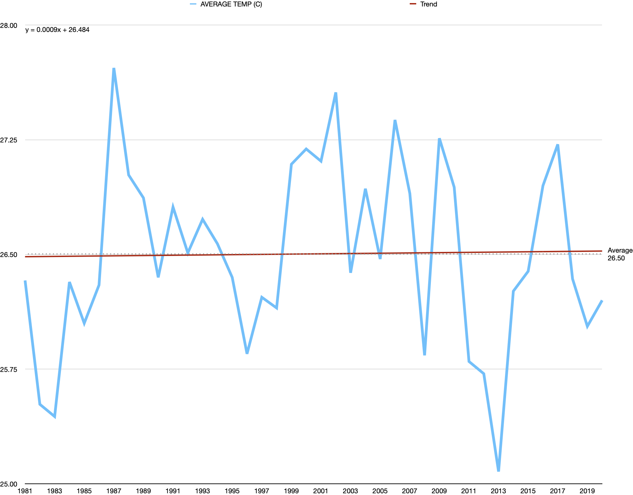

* Equation of trend: y = 0.0009x + 26.484
* Trend depicts an overall increment in temperature of the location
* Average value = 26.500 C

#### Precipitation

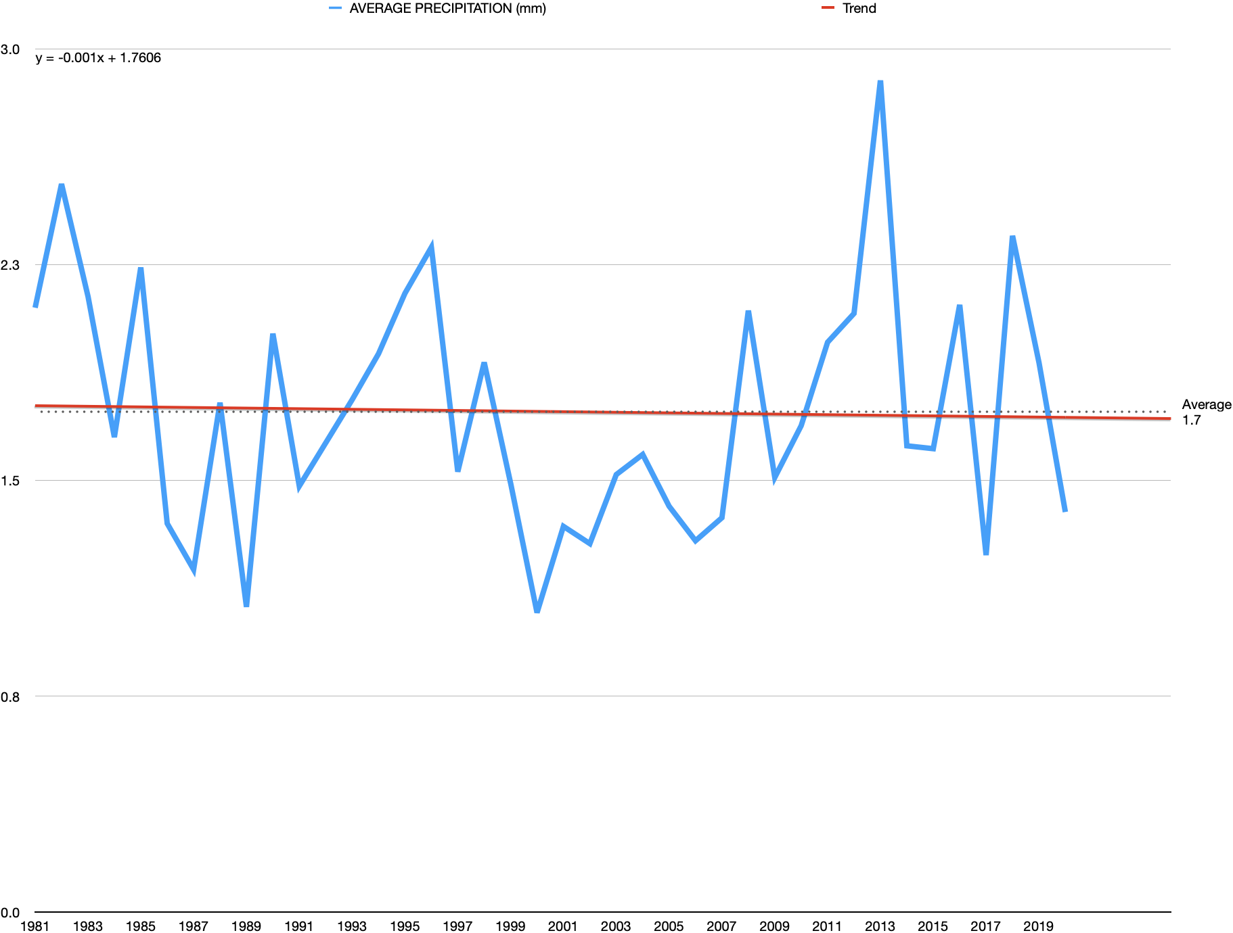

* Equation of trend: -0.001x + 1.7606
* Trend depicts an overall drop in annual rainfall recieved.
* Average value = 1.7 mm

Overall, the place under observation, AGRA, shows an increment in temperature with a decrement in annual rainfall, depicting the climate heading towards a dry spell.